**Step 1. User will key enter their business registration number using following form**  
  
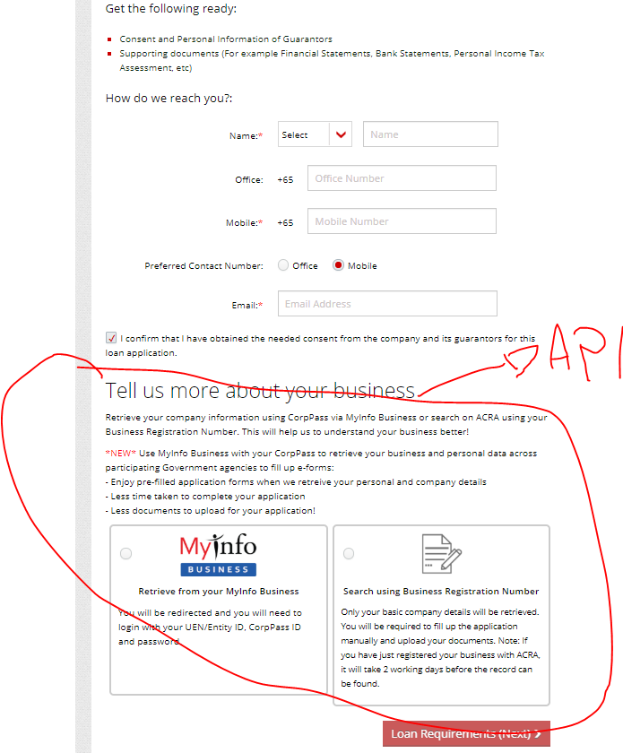

**Step 2. Pop out showing the company details**  
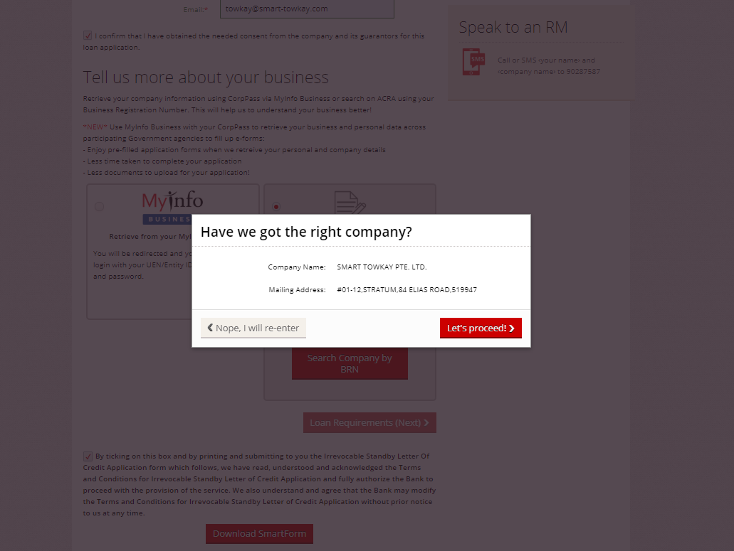

**Step 3. Filling of business information**

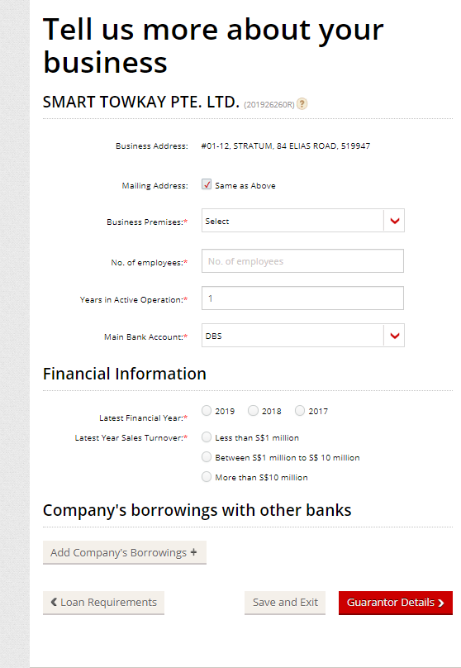

**Step 4. Personal director/shareholder details: these details are retrieved from API**  
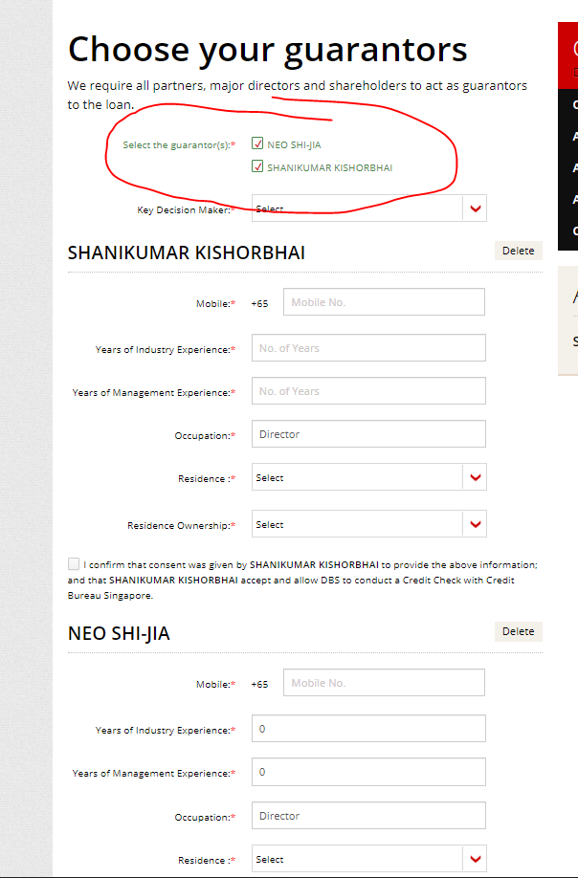

**Step 5. Upload documents**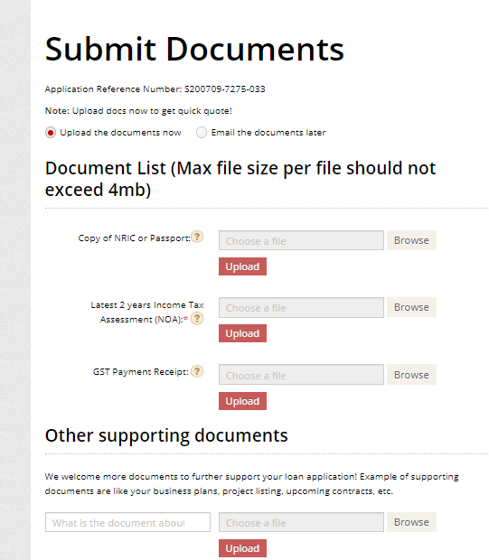

Step 6: show following data  
  
  
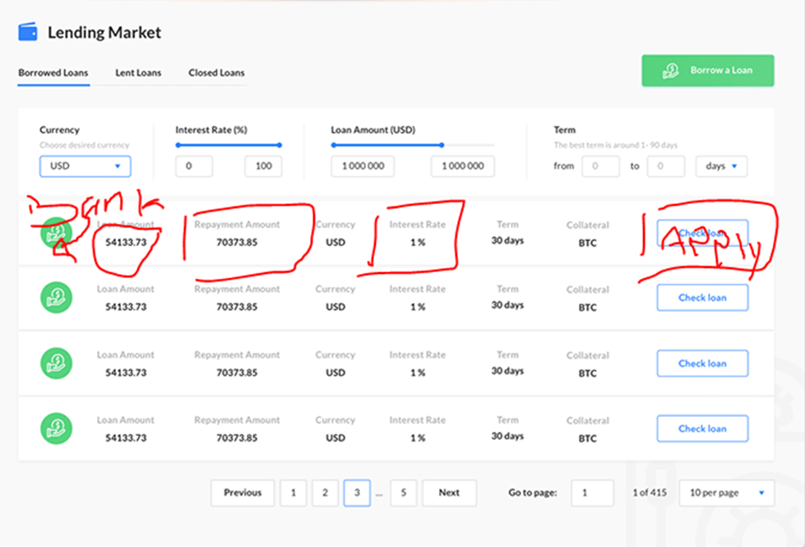

Remember following theme will be used to design all the forms. Remember the the steps show what fields to be included in form and the theme (color and looks will be made like below image). The forms should also be responsive

